**3. Create Ingress k8s manifest with default backend**

--- Reference - <https://github.com/stacksimplify/aws-eks-kubernetes-masterclass/tree/master/08-NEW-ELB-Application-LoadBalancers/08-02-ALB-Ingress-Basics>

**Review Ingress kube-manifest with Default Backend Option**

--- Annotations - <https://kubernetes-sigs.github.io/aws-load-balancer-controller/v2.4/guide/ingress/annotations/>

--- File Location: **01-kube-manifests-default-backend/02-ALB-Ingress-Basic.yml**

# Annotations Reference: https://kubernetes-sigs.github.io/aws-load-balancer-controller/latest/guide/ingress/annotations/

apiVersion: networking.k8s.io/v1

kind: Ingress

metadata:

  name: ingress-nginxapp1

  labels:

    app: app1-nginx

  annotations:

    # Load Balancer Name this annotation is comes from the above link.

    alb.ingress.kubernetes.io/load-balancer-name: app1ingress

    #kubernetes.io/ingress.class: "alb" (OLD INGRESS CLASS NOTATION - STILL WORKS BUT RECOMMENDED TO USE IngressClass Resource) # Additional Notes: https://kubernetes-sigs.github.io/aws-load-balancer-controller/v2.3/guide/ingress/ingress_class/#deprecated-kubernetesioingressclass-annotation

    # Ingress Core Settings

    alb.ingress.kubernetes.io/scheme: internet-facing # whether the load balancer internet facing or internal facing. You will find it in schema annotations. Here I am creating internet facing load balancer.

    # Health Check Settings

    alb.ingress.kubernetes.io/healthcheck-protocol: HTTP

    alb.ingress.kubernetes.io/healthcheck-port: traffic-port

    alb.ingress.kubernetes.io/healthcheck-path: /app1/index.html

    alb.ingress.kubernetes.io/healthcheck-interval-seconds: '15'

    alb.ingress.kubernetes.io/healthcheck-timeout-seconds: '5'

    alb.ingress.kubernetes.io/success-codes: '200'

    alb.ingress.kubernetes.io/healthy-threshold-count: '2'

    alb.ingress.kubernetes.io/unhealthy-threshold-count: '2'

spec:

  ingressClassName: my-aws-ingress-class # Ingress Class

  defaultBackend:

    service:

      name: app1-nginx-nodeport-service # here you have to mention the node port service, because the request first goes to the ingress load balancer and from there it will goes to the node port service.

      port:

        number: 80

# 1. If  "spec.ingressClassName: my-aws-ingress-class" not specified, will reference default ingress class on this kubernetes cluster

# 2. Default Ingress class is nothing but for which ingress class we have the annotation `ingressclass.kubernetes.io/is-default-class: "true"`

--- **note** – using single application load balancer, we can send traffic to multiple applications with different schemes, you have only one application here that is why you define **alb.ingress.kubernetes.io/healthcheck-path: /app1/index.html** this as a global. If you have more applications then there might be chance that this path(**/app1/index.html)** is won’t be there.

--- in this types of scenario, we will move this **alb.ingress.kubernetes.io/healthcheck-path: /app1/index.html** to node port service manifest.

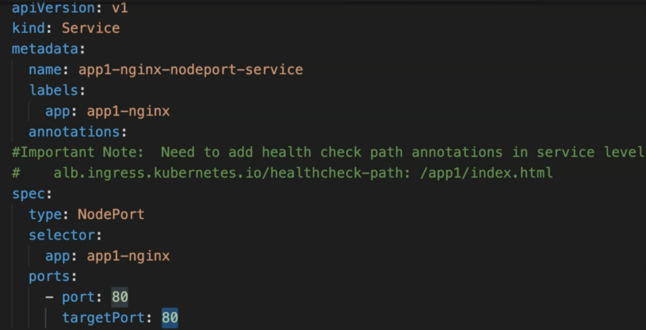

--- under annotations, we can move them.

--- **Important Note**: Need to add health check path annotations in service level if we are planning to use multiple targets in a load balancer alb.ingress.kubernetes.io/healthcheck-path: /app1/index.html